**ASSIGNMENT 3**

**Roll no – A-44**

**Code –**

import numpy as np

import pandas as pd

df = pd.read_csv("Ass3.csv")

print(df.shape)

sample_size = int(0.3 * len(df))

sample = np.random.choice(df.index, size = sample_size, replace = False)

print("SAMPLE: ", sample)

sample_df = df.loc[sample]

print(sample_df)

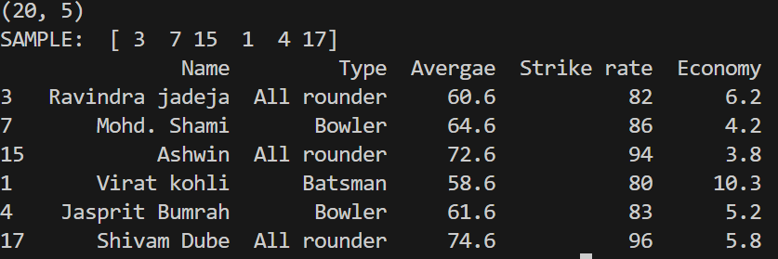**Output –**

**Csv file-**

Name,Type,Avergae,Strike rate,Economy

MS dhoni,Wk batsman,57.6,79,

Virat kohli,Batsman,58.6,80,10.3

Rohit Sharma,Batsman,59.6,81,9.2

Ravindra jadeja,All rounder,60.6,82,6.2

Jasprit Bumrah,Bowler,61.6,83,5.2

Shubhman Gill,Batsman,62.6,84,

Yashaswi jaiswal,Batsman,63.6,85,5.2

Mohd. Shami,Bowler,64.6,86,4.2

Mohd. Siraj,Bowler,65.6,87,3.2

Kuldeep Yadav,Bowler,66.6,88,2.2

Ruturaj Gaikwad,Batsman,67.6,89,

Shardul Thakur,All rounder,68.6,90,0.2

Rinku singh,Batsman,69.6,91,0.8

SKY,Batsman,70.6,92,

Axar Patel,All rounder,71.6,93,2.8

Ashwin,All rounder,72.6,94,3.8

KL Rahul,Wk batsman,73.6,95,

Shivam Dube,All rounder,74.6,96,5.8

Bhuvi ,Bowler,75.6,97,6.8

Yuzi Chahal,Bowler,76.6,98,7.8